**A Scalable Deep Learning Approach for Accurate Dog Breed Identification**

**Abstract**

Dog breed identification is an image recognition problem at high resolution, which has high visual similarity for some breeds. In this work, we propose an effective deep learning method based on transfer learning for dog-breed identification from images at high precision. With the use of a pre-trained convolutional neural network for feature extraction and light-weight fully connected classifier, our strategy provides robust performance while avoiding complexity. The approach is trained against an extensive benchmark dataset and evaluated using standard metrics, revealing its effectiveness in learning discriminative features for different breeds. Regularization through dropout and early stopping prevent overfitting and ensure generalization. Results support our solution as an effective and reliable solution for real-world applications in pet identification, veterinary diagnostics, and animal welfare networks.

**Keywords:** Dog Breed Identification, Transfer Learning, Convolutional Neural Networks (CNNs), Image Classification, Fine-Grained Recognition

**Introduction**

Dog-breed identification is an image classification task with fine granularity wherein visually related categories have subtle visual differences. It is an extremely difficult problem because intra-class variation is high while inter-class variance is low. Accurate identification has real-world applications in pet identification, veterinary diagnosis, and animal welfare monitoring.

Traditional machine learning algorithms based on manually designed features tend to be ineffective at capturing dog breeds' complexity. Deep learning models, however, especially convolutional neural networks (CNNs), have proven highly capable of learning robust visual representations automatically from unprocessed image data.

In this paper, we introduce an effective deep learning methodology using transfer learning for dog breed identification. We employ a fixed feature extractor in the form of a pre-trained InceptionResNetV2 and train a light dense neural network over the extracted features for ultimate classification. This approach tends to bring down computational expense quite dramatically while delivering high precision.

To promote generalization, we use dropout and early stopping in training. We test our approach using one benchmark dataset and show state-of-the-art performance over diverse breeds, indicating our approach can be scaled and deployed for practical use.

**Literature Survey**

For classifying 120 dog breeds, this research suggests a pretrained deep CNN structure based on transfer learning. In this research report, the accuracy of the model on the Stanford dog’s dataset for training stood at 95.03% and for validation at 92.92%. After testing on internet images, the network achieved an ideal solution in classifying fine-grained breeds in dogs accurately at an accuracy level of 88.92%[1]. Dogs are associated with problems like rabies, vaccination, ownership, and population management. More than 180 breeds of dogs have distinct features and diseases. There is research that introduces deep learning and traditional methods for classifying dogs. An improved retrained CNN structure outperforms the HOG descriptor with accuracy at 96.75 %, showing it is effective in classifying dogs' breeds[2]. An improved ResNet classifying method that reduces misclassification and enhances accuracy for domestic breeds of dogs is outlined in the research report. The method is effective in Chinese research on dogs as it attains precision, recall, and F1-score higher than the traditional Chinese dogs' breeds[3]. There is research that suggests a new combined model based on YOLOv7 with WOA in Convolutional Neural Network (CNN) that accurately classifies dog breeds. It has been tested via the Stanford Dogs dataset and found it is superior in accuracy compared to the prevailing methods. It is valuable in veterinary service, studies on the behaviour of dogs, as well as pet administration systems. It illustrates the merits of uniting machine learning methods in its advanced form with nature-inspired methods[4]. From research in this study, most brachycephalic "screw-tail" dogs with typical neurological development had defective vertebrae; the prevalence is found to be lower in Pugs as compared to French Bulldogs. French as well as British Bulldogs were found to be prone to ventral hypoplasia. Prevalence of CVM was uninfluenced by sex[5].

The "myPUP" pet-oriented app applies machine learning and Convolutional Neural Networks for prediction of breeds, provision of breed-specific information, and healthcare advice. It has an additional helpline for health prediction based on behavioural patterns as well as a scanner for purity check [6]. This research explores behavioural correlations in relation to neutering in male breeds of dogs. There were two clades with 136 intact as well as neutered dogs; "Huskies" and "Bulldogs". It was found that neutered dogs showed higher aggression towards people and stress-related expressions based on castration status as well as breed. There were more stresses as well as uncertainty in the case of neutered animals, with higher stress in "Bulldogs". It stresses the dangers as well as adverse consequences of neutering [7]. Dogs are difficult in terms of population management, control of rabies, vaccination control, as well as possibility of lawfulness in ownership. Machine learning as well as Convolutional Neural Networks (CNNs) can recognize dogs in multi-modal imagery, showing great analysis accuracy for various tested datasets [8].

It outlines a deep learning system for breed determination of dogs in images based on convolutional neural networks. Two distinct networks are designed as well as tested on the dataset of Stanford Dog's dataset. It employs a software device with server as well as cellular client for both on-line as well as off-line comparisons [9]. It utilized machine learning for automatic classification of canines based on personality types based on behavioural information of the project of C-BARQ project. There were five distinct groups of dogs found, for which the decision tree model showed the best performance with a value of 99%. This AI-based approach can improve choice as well as training of dogs for specific tasks [10].

**Proposed System**

This proposed approach uses a transfer learning methodology to classify dog breeds based on images. We use a pre-trained InceptionResNetV2 model as a fixed feature extractor rather than constructing a convolutional neural network (CNN) from scratch. This method shortens training times and enhances generalization performance for comparatively smaller datasets by utilizing the representational strength of deep convolutional layers trained on the extensive ImageNet dataset.

Dataset utilized in this research is Dog Breed Identification dataset that comprises 10,222 images belonging to 120 different breeds of dogs, specifically curated for fine grained image classification applications. It is generated out of ImageNet containing bounding box annotations as well as class labels in order to assist in proper training as well as evaluation.

**Figure 1:** System Architecture

**Data preprocessing steps**

A data augmentation pipeline was generated using TensorFlow and Keras ImageDataGenerator. Pixel values are rescaled to [0, 1] [0,1], random rotations ($±{40}^{∘}$), shifts ($±30\%$), shear, zoom ($±30\%$) and horizontal flipping, these are the augumentations applied on training data. By adding variability to the dataset, these augumentations enhanced model generalization and reduced overfitting. Only rescalling the test and validation datasets-maintained evaluation consistency.

After making the modifications and providing batches for model evaluation and training, dynamic generators uploaded images from file directories.

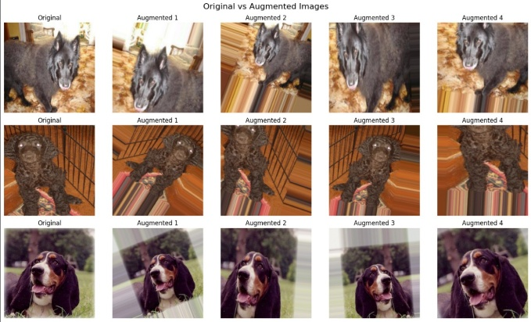

**Figure 2:** Augmented Images

The effectiveness of the augmentation pipeline was confirmed by visualizing a subset of the original and augmented images. While augmented images represented modifications like rotation, flipping and scaling, original images were displayed as loaded. The pipelines’ ability to dynamically generate a variety of training samples has been confirmed by this visualization.

Using OpenCV, images were resized to 224 $×$ 224 and normalized to [0, 1]. This stage of preprocessing maintained visual quality while ensuring consistency with the models input dimensions. To verify the changes, sample comparisons between original and processed images were made. Figure 4 shows the image after resizing and normalizing it.

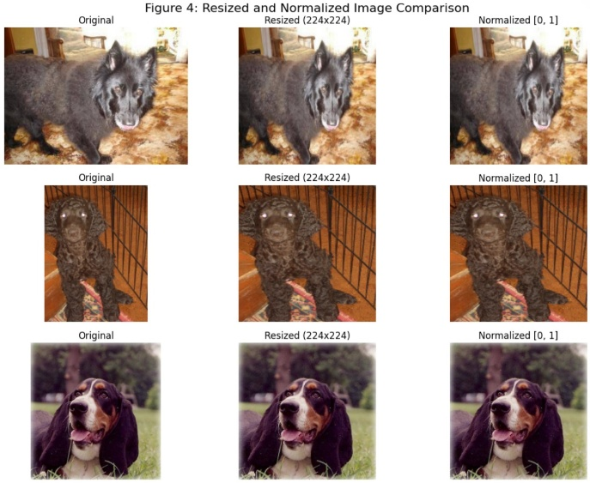

**Figure 3:** Resized and Normalized image

Using RandomOverSampler from imblearn class imbalance was addressed by duplicating minority class samples in order to create a uniform distribution. To balance the dataset, oversampling was used and labels were numerically encoded. Class distributions before and after oversampling were demonstrated, enduring consistent representation across classes and decreasing the possibility of bias during model training.

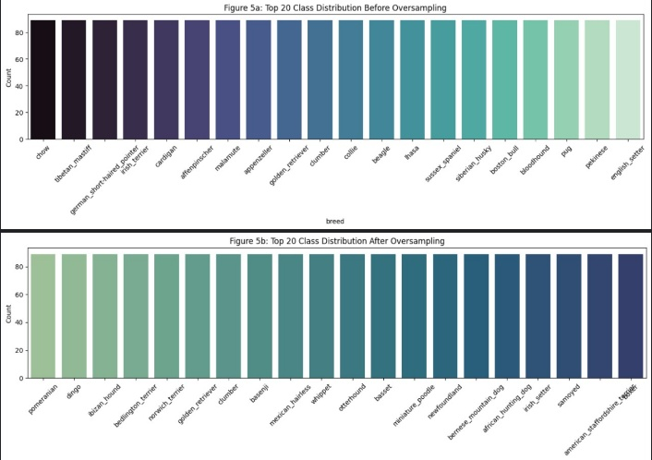

**Figure 4:** Class Distribution Before and After Oversampling

**Methodology**

**Feature Extraction Using Pre-trained CNN**

The RGB input of the i-th sample should be represented by each image $x_{i}∈R^{299×299×3}$, scaled to the input shape needed by the InceptionResNetV2 model. After removing the top classification layers from a pretrained CNN $∮$, we run $x_{i}$ to produce a feature map:

$$f_{i}=∮\left(x_{i}\right), f_{i}∈R^{h×w×d}$$

The final feature map dimensions for InceptionsResNetV2 are $h=8, w=8$ and $d=1536$, and yeilding a total of $8×8×1536=98304$ features per image.

One dimensional feature vectors are then created by flattening these feature tensors:

$${\tilde{f}}_{i}=vec\left(f_{i}\right)∈R^{1×hwd}=R^{1×98304}$$

The integration with conventional dense layers for classification is made possible by this flattening phase.

**Neural Network Classifier**

Two hidden layers with ReLU activations and Dropout regularization to lessen overfitting make up the fully connected neural network that serves as the classification head. A SoftMax classifier that maps to a probability distribution across $C$ dog breed classes makes up the output layer.

Let’s define the transformations as follows:

$$z_{1}=ReLU\left({\tilde{f}}_{i}W_{i}+b_{1}\right), {z'}_{1}=Dropout(z_{1},p=0.2)$$

$$z_{2}=ReLU\left({z^{'}}_{1}W_{2}+b_{2}\right), {z'}_{2}=Dropout(z_{2},p=0.2)$$

$${\hat{y}}_{i}=Softmax({z^{'}}_{2}W_{3}+b_{3})$$

Where:

* $W_{1}∈R^{98304×512}, W_{2}∈R^{512×512},$ and $W_{3}∈R^{512×C}$
* $b_{1}, b_{2}, b_{3}$ are bias terms
* ${\hat{y}}_{i}∈R^{C}$ is the predicted class probability vector

**Loss Function and Optimization**

In order to minimize the sparse categorical cross-entropy loss, the model is trained:

$$L=-\sum_{i=1}^{N}{log⁡({\hat{y}}_{i,y_{i}})}$$

Where:

* $N$ is the number of training samples
* $y_{i}∈\left\{0, 1, …, C-1\right\}$ is the true label of sample $i$
* ${\hat{y}}_{i,y_{i}}$ is the predicted probability of the correct class

The Adam optimizer, which adaptively modifies learning rates for every parameter, is used to carry out optimization:

$$θ_{t+1}=θ_{t}-α∙\frac{m_{t}}{\sqrt{V_{t}}+ϵ}$$

Where the first and second moment estimates of the gradients are denoted by $m_{t}$ and $v_{t}$ respectively.

**Regularization and Validation**

Two mechanisms are used to avoid overfitting:

* Dropout: Applied with a drop rate of $p=0.2$ to every concealed layer.
* Early Stopping: Tracks validation loss and stops training after a predetermined number of epochs (patience = 10) without seeing any improvement.

With a batch size of 64 and a validation split of 10%, the training process is run for up to 50 epochs.

**Result and Discussions**

The trained system was validated through one benchmark dataset against standard measures of classification. In training, the system achieved an impressive 92.67% accuracy at its corresponding loss of 0.3195, showing learning of discriminative breed features against training data. In validation data, likewise, the system achieved 86.90% accuracy and at 0.8465 loss in validation, showing good generalization to unseen data. Training-validation difference in accuracy is quite negligible, showing that, through regularization mechanisms of dropout and early stopping, overfitting was avoided.

The experiments confirm using feature extraction through a trained InceptionResNetV2 in combination with an optimized dense classifier to obtain an accurate and computationally-effective solution for dog fine-grained identification. Its success across an extremely diverse set of breeds testifies its strength in learning discriminative representations for even extremely inter-class similar classes. Results confirm suitability of the strategy for use in real-world high-precision and efficiency requirements, for instance mobile animal identification scenarios, or welfare monitoring in assistive environments.

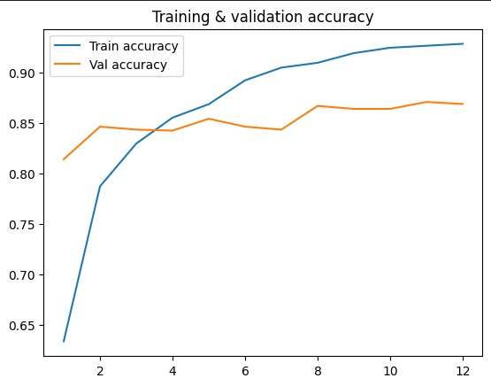

**Figure 6:** Training and Validation accuracy

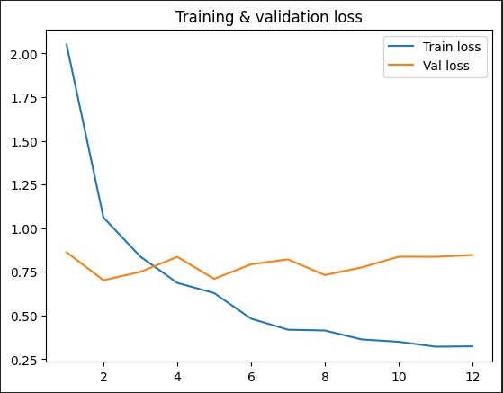

**Figure 7:** Training and validation Loss

**Conclusion**

In this paper, we proposed an effective and efficient dog breed identification strategy using transfer learning. With feature extraction based upon using an InceptionResNetV2 pre-trained neural network and a light-weight fully connected classifier for generating final predictions, our approach achieved high-classification rates while experiencing low-computational complexity. With good performancs against training data using a benchmark dataset, our approach achieved train accuracy of 92.67% and validation accuracy of 86.90%, which testifies to its generative capacity using unseen data. Regularization processes in terms of dropout and early stopping further contributed its robustness by protecting against overfitting. In conclusion, our strategy is validated as an industrially practical and scalable solution for practical cases in pet identification, veterinary pathology, and in animal welfare modules. Future developments can further explore using compression algorithms within the approach for use in practical cases within mobile devices and re-implementation of attention mechanisms for further enhancing its differentiation for visually related breeds.

**REFERENCES**

1. Manivannan, S., & Venkateswaran, N. (2023, January). Dog Breed Classification using Inception-ResNet-V2. In *2023 International Conference for Advancement in Technology (ICONAT)* (pp. 1-5). IEEE.
2. Borwarnginn, P., Thongkanchorn, K., Kanchanapreechakorn, S., & Kusakunniran, W. (2019, October). Breakthrough conventional based approach for dog breed classification using CNN with transfer learning. In *2019 11th International Conference on Information Technology and Electrical Engineering (ICITEE)* (pp. 1-5). IEEE.
3. Zhang, X., Shen, C., Xu, J., Yuan, F., Li, C., & Liu, X. (2024, March). Chinese Native Dog Breed Classification Method based on Improved ResNet. In *2024 7th International Conference on Information and Computer Technologies (ICICT)* (pp. 244-249). IEEE.
4. Singh, A., Kothari, R., & Arulalan, V. (2024, April). Dog Breed Detection using YOLOv7 and WOA-CNN. In *2024 10th International Conference on Communication and Signal Processing (ICCSP)* (pp. 1477-1482). IEEE.
5. Moses, W. B., Moses, I. A., Moses, E. A., & Moses, P. A. (2024). Prevalence and classification of congenital thoracic vertebral body abnormalities in neurologically normal brachycephalic ‘screw‐tail’dog breeds in referral practice in Australia. *Australian Veterinary Journal*.
6. Chadha, R. S., Tomer, P., Singh, A., & Patil, S. D. (2024, February). Canine breed identification using machine learning on Android. In *AIP Conference Proceedings* (Vol. 2742, No. 1). AIP Publishing.
7. Kolkmeyer, C. A., Baum, J., Warlich-Zach, N., & Gansloßer, U. (2024). From “Husky” to “Bulldog”–behavioural correlates between castration and breed groups in the domestic dog (Canis lupus familiaris). *BMC Veterinary Research*, *20*(1), 238.
8. Sarvakar, K., Salot, P., Pancholi, P., & Gondalia, A. Multi-View Dog Breed Classification: Integrating Image-Based and Metadata Approaches with Machine Learning.
9. Kishore, P. Y. N. D., & Gohin, B. Deep Learning Models-Based Dog Breed Recognition System.
10. Amirhosseini, M. H., Yadav, V., Serpell, J. A., Pettigrew, P., & Kain, P. (2024). An artificial intelligence approach to predicting personality types in dogs. *Scientific Reports*, *14*(1), 2404.
11. Li, J., & Zhang, Y. (2024). Regressive vision transformer for dog cardiomegaly assessment. *Scientific Reports*, *14*(1), 1539.
12. Cui Y, Tang B, Wu G, Li L, Zhang X, Du Z, Zhao W. Classification of Dog Breeds Using Convolutional Neural Network Models and Support Vector Machine. Bioengineering (Basel). 2024 Nov 17;11(11):1157. doi: 10.3390/bioengineering11111157. PMID: 39593817; PMCID: PMC11591900.
13. Towpunwong, N., & Sae-Bae, N. . (2023). Dog Breed Classification and Identification Using Convolutional Neural Networks. *ECTI Transactions on Computer and Information Technology (ECTI-CIT)* , *17* (4), 554–563. <https://doi.org/10.37936/ecti-cit.2023174.253728>
14. Agarwal, A. K. ., Kiran, V. ., Jindal, R. K. ., Chaudhary, D. ., & Tiwari, R. G. . (2022). Optimized Transfer Learning for Dog Breed Classification. *International Journal of Intelligent Systems and Applications in Engineering*, *10*(1s), 18–22. Retrieved from <https://ijisae.org/index.php/IJISAE/article/view/2233>
15. Ráduly, Z., Sulyok, C., Vadászi, Z., & Zölde, A. (2018, September). Dog breed identification using deep learning. In *2018 IEEE 16th International Symposium on Intelligent Systems and Informatics (SISY)* (pp. 000271-000276). IEEE.